**High-Level Summary**

**Terra Guard -** educational strategy game where players make decisions related to climate protection, waste management, and the environment.

Every decision players make directly influences the health of our planet, forging meaningful connections in different places across Earth's ecosystems.

Your mission? Preserve the balance of our world and avert disaster!

Earn points and unlock badges by making impactful decisions that lead to a sustainable future!

**Project Demo**

**Final Project**

**Project Details**

Simple daily choices greatly impact the environment worldwide. For instance, opting for single-use plastics in Europe contributes to ocean pollution, affecting marine life and ecosystems on islands in Thailand.

"Every great journey starts with a single step - let yours guide others toward change"

**Terra Guard** invites players to embark on an engaging mission in interactive format, creating a ripple effect across the globe!

For example, when a player in Tokyo chooses an eco-friendly bag over a plastic one, it triggers a chain reaction impacting the Great Pacific Garbage Patch - leading to a young albatross struggling to take flight due to plastic contamination in its food. What happens when that single choice is made by 10, 1000 or even a million people every day?

Select starting location, select who you must rescue. Then take on challenges, make choices, take actions, see the scale of your decision. Witness the effect on the other places on Earth on a map. Remember to keep data from sensors in the optimal condition, one wrong choice can lead to a drop in readings from a sensor on the other side of the Earth, which will result in mission failure. The impact map you draw, shapes your awareness. Gain points, badges, earn NASA ECO HERO certificate!

We target ages 12-35, including high school and university students, as well as parents with kids education. Our goal is to become a flagship educational product for organizations like NASA, ESA, WHO or POLSA focusing on Earth observation and climate protection education!

We envision every school using our game in lessons on climate change, with a platform for teachers to create custom scenarios. Top performers receive discounts on engineering courses and satellite images from partners like NASA, ESA, and PCI, as well as potential internship offers, that will motivate them to actively participate in the game and constantly make it better and better!

**TERRA GUARD** -game raises awareness and motivates young people to save the planet Earth through simple and effective actions related to ecology, transportation, and effectively responding to negative changes on the planet. We believe that gamification combined with a reward system will encourage young people to engage and take action, providing schools and universities with a powerful educational tool that meets the capabilities of the 21st century.

**Main hack**

Our main hack is built on **three** pillars:

* Visualizing the global impact of one action to other places on the planet
* The scale effect: What if a thousand, a million people would made this choice?
* Gamification and a reward system to motivate and engage young people

**How it works in details - tutaj załączyć dokładnie screeny (gif, video?)**

Link to video -

**What do we want to achieve?**

Our goal is to become a flagship educational product for organizations like NASA, ESA, POLSA, WHO focusing on Earth observation and climate protection education!

**How do we get to that solution?**

We considered many solutions on how to activate the community and educate young people in the most effective way. Initially, we thought about mobile applications where users upload photos of their activities while completing challenges. However, we decided to focus on a unified platform and direct the idea towards an educational platform. During the discussion, we decided that we want to **emphasize a game** where the dependency map between the player’s actions is very clearly visible. Additionally, we wanted to maximally engage the player in the role responsible for preventing the mission objective from extinction. We tried to challenge our solution with many mentors, also searching if similar solutions already exist on the internet, and we queried ChatGPT to find gaps in our solution.

**Target users**

Our primary audience and users are young people aged 12-35, including high school students, university students, and parents with children. We aim for our game to become a flagship product for NASA, ESA, POLSA, and other organizations involved in Earth observation and climate protection.

We envision every school using our game in lessons about Earth observation and climate change, with our platform allowing teachers to create their own scenarios. Users who successfully complete missions earn points and badges. For top performers, partnering organizations like NASA, ESA, PCI, and others will offer discounts on courses and satellite images. The best might even receive internship offers!

**Competitors**

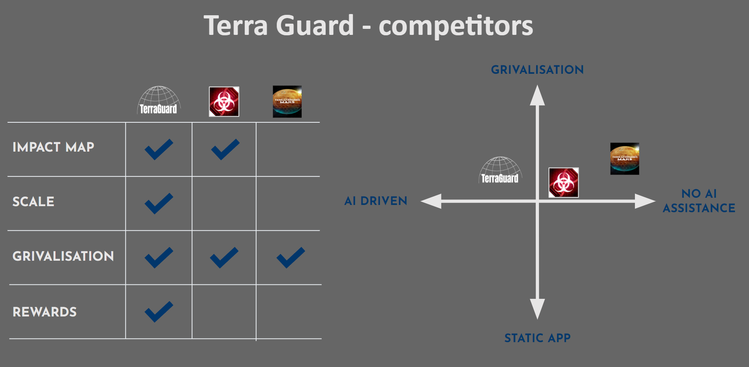

**Use of Artificial Intelligence**

**ChatGPT** - to challenge our ideas and spot potential problems early on. By embodying different roles - like a harsh judge, hackathon juror, and timekeeper - it helped us critically assess our approach.

**Cursor AI** - to assist with programming, which made the coding process smoother.

**Space Agency Data**

[**NASA Explores Earth’s Interconnected Systems**](https://www.youtube.com/watch?v=96qR72QM0OI)

[**What NASA Knows from Decades of Earth System Observations**](https://www.youtube.com/watch?v=dzmktnXUZag)

[**World Map from NASA's Open Data Portal**](https://data.nasa.gov/dataset/World-Map/7zbq-j77a)

[access 06.10.2024]

**1**

**References**

**<TODO>**

[**https://power.larc.nasa.gov/docs/services/api/**](https://power.larc.nasa.gov/docs/services/api/)

**WIP:**

**Tools:** HitFilm, OBS, Figma, ChatGPT, Google Docs, Javascript, Angular

**Images:**

<https://data.nasa.gov/dataset/World-Map/7zbq-j77a>

* jak doszliśmy do tego rozwiązania
* jaki problem chcemy poruszyć (jak jedna osoba zmieni nawyki, to “nic” się nie zmieni, jak zrobi to “10000” osób zmieni się wszystko)
* konkurencja
* w jakiego użytkownika celujemy jak go możemy spersonifikować (do jakiej społeczności celujemy nasze rozwiązanie)
* zaznaczyć problem skali i uświadomienia
* jak zaangażujemy społeczność do korzystania z naszej gry
* jak wykorzystywaliśmy AI do rozwiązywania naszego challengu (trzeba tutaj coś nieoczywistego dać - looknąć na linkedin na Cursor jakiś tool to tworzenia filmików)
* Konkrety odnośnie sensorów i źródeł z których pobieramy dane
* Efekt motyla, mechanizm nagrody?